AI-BASED INTERVIEW SIMULATOR WITH INTELLIGENT FEEDBACK

The domain of the Project: Artificial Intelligence

COURSE NAME

Project-Based Internship in Artificial Intelligence & Machine Learning

Team Mentors (and their designation): Gaurav Patel -Data Engineer

Team Members:

Ms. Muthyala Deepika Reddy

Period of the project

May 2026 to June 2026

Declaration
The project titled “AI-Based Interview Simulator With Intelligent Feedback” has been mentored by Gaurav Patel, organised by SURE Trust, from December to June 2026, for the benefit of the educated unemployed rural youth for gaining hands-on experience in working on industry relevant projects that would take them closer to the prospective employer. I declare that to the best of my knowledge the members of the team mentioned below, have worked on it successfully and enhanced their practical knowledge in the domain.

Team Members:
Ms. Muthyala Deepika Reddy
Signature M.Deepika

Mentor’s Name Gaurav Patel Mentor’s Name Gaurav Patel
Designation—Company Name Designation—Company Name
Data Engineer Data Engineer

Prof. Radhakumari
Executive Director & Founder
SURE Trust

Table of contents
- Executive summary
- Introduction
- Project Objectives
- Methodology & Results
- Social / Industry relevance of the project
- Learning & Reflection
- Future Scope & Conclusion

Executive Summary
AI-Powered Interview Preparation System is developed to help students and job seekers improve their interview skills through an intelligent and interactive platform. The main objective of this project is to provide a realistic interview practice environment where users can answer technical and HR interview questions and receive instant AI-based feedback. The system aims to improve technical knowledge, communication skills, and overall interview confidence.
The project is developed using Python, Streamlit, Groq LLM, gTTS, and Speech Recognition. It generates interview questions based on the selected domain and difficulty level. The AI evaluates each answer and provides scores, strengths, weaknesses, improvement suggestions, and an ideal answer. The system also includes voice-based features, allowing users to listen to interview questions and answer using voice, making the interview experience more interactive and practical.
The key findings of this project show that AI can provide personalized feedback and help users identify their mistakes, improve their responses, and prepare more effectively for real interviews. The additional features, such as Review My Interview and Learn Interview Questions, further support users by analyzing real interview answers and explaining important interview concepts.
It is recommended that this system be enhanced in the future by adding features such as resume-based interview question generation, multilingual support, video interview analysis, emotion detection, and detailed performance tracking. These improvements will make the platform more intelligent, user-friendly, and beneficial for students, fresh graduates, and job seekers preparing for different types of interviews.

Introduction

Background and Context of the Project

Interviews are an important part of the recruitment process for students and job seekers. Many candidates have good technical knowledge but find it difficult to perform well in interviews because of a lack of confidence, practice, and proper guidance. Traditional interview preparation methods often do not provide personalized feedback or a realistic interview experience. With the growth of Artificial Intelligence, it is now possible to create intelligent systems that help users practice interviews and receive instant feedback. The AI-Powered Interview Preparation System is developed to provide a smart, interactive, and user-friendly platform for interview preparation.

Problem Statement
Many students and fresh graduates face difficulties in preparing for technical and HR interviews due to limited access to mock interviews and expert feedback. Existing platforms may not provide personalized evaluation or detailed suggestions for improvement. The main goal of this project is to develop an AI-based interview simulator that generates interview questions, evaluates user answers, provides detailed feedback, and helps users improve their interview performance and confidence before attending real interviews.

Scope and Limitations of the Project
The system supports multiple interview domains, including Python, Machine Learning, Data Science, AI/ML, Web Development, and HR interviews. Users can select the interview domain, difficulty level, and number of questions. The application generates interview questions, evaluates answers, provides scores, strengths, weaknesses, improvement suggestions, and ideal answers. It also includes voice-based features, interview review, and concept learning modes.
The current version has some limitations. The quality of the evaluation depends on the AI model and the user's responses. It requires an internet connection to access AI services, and it currently supports only the available interview domains. Features such as resume-based interviews, video interview analysis, emotion detection, and multilingual support are not included in this version.

Innovation Component in the Project

The main innovation of this project is the integration of Artificial Intelligence with interview preparation. Unlike traditional mock interview systems, this application generates intelligent interview questions and provides personalized feedback using a Large Language Model. It also combines text-to-speech and speech-to-text technologies to support voice-based interviews, creating a more realistic interview experience. The additional features, such as Review My Interview and Learn Interview Questions, make the system more interactive and useful for continuous learning and interview preparation.

Project Objectives
Objectives of the Project
- The main objective of the AI-Powered Interview Preparation System is to help students and job seekers prepare for technical and HR interviews through an intelligent and interactive platform. The project aims to provide a realistic interview experience by generating AI-based interview questions and evaluating user responses with personalized feedback.
- The specific objectives of the project are:
- To develop an AI-based interview preparation platform using Python and Streamlit.
- To generate domain-specific interview questions based on the user's selected domain and difficulty level.
- To evaluate user answers and provide technical, communication, and completeness scores.
- To identify the strengths and weaknesses of the user's answers and provide improvement suggestions.
- To support text-based and voice-based interview practice using text-to-speech and speech-to-text technologies.
- To provide Review My Interview and Learn Interview Questions features to help users analyze answers and learn interview concepts.
- To improve users' confidence, communication skills, and interview performance before attending real job interviews.
Expected Outcomes and Deliverables
- The expected outcome of this project is an intelligent interview preparation system that helps users practice interviews and receive instant AI-based feedback. The application provides a realistic interview environment where users can improve their knowledge, communication skills, and confidence.
- The final deliverables of the project include:
- A fully functional AI-Powered Interview Preparation System.
- AI-generated interview questions with intelligent answer evaluation and detailed feedback.
- Voice-based interview support using text-to-speech and speech-to-text.
- Interview review, learning modules, and a final performance report.
- Source code, project documentation, and deployment on Streamlit.
Methodology and Results
Methods / Technology Used
The project was developed using Python as the programming language and Streamlit for building the user interface. Groq LLM was used to generate interview questions, evaluate user answers, and provide feedback. gTTS (Google Text-to-Speech) was used to read interview questions aloud, while Speech-to-Text technology was used to convert voice responses into text for evaluation.

Tools / Software Used
- Python
- Streamlit
- Groq LLM
- gTTS (Google Text-to-Speech)
- Speech Recognition
- Streamlit Mic Recorder
- Visual Studio Code
- GitHub

Data Collection Approach
The project does not use a fixed dataset. Interview questions and feedback are generated dynamically using the Groq Large Language Model based on the selected interview domain and difficulty level. User responses are collected through text or voice input and evaluated in real time.

Project Architecture
The system begins by allowing users to select the interview mode, domain, difficulty level, and number of questions. The Groq LLM generates interview questions based on these selections. Users answer the questions using text or voice input. Voice responses are converted into text using Speech-to-Text technology. The AI then evaluates the answers and provides scores, strengths, weaknesses, improvement suggestions, and ideal answers. Finally, the application generates a performance report summarizing the user's interview results.

Final Project Working Screenshots
- Home Page (Interview Settings and Mode Selection)
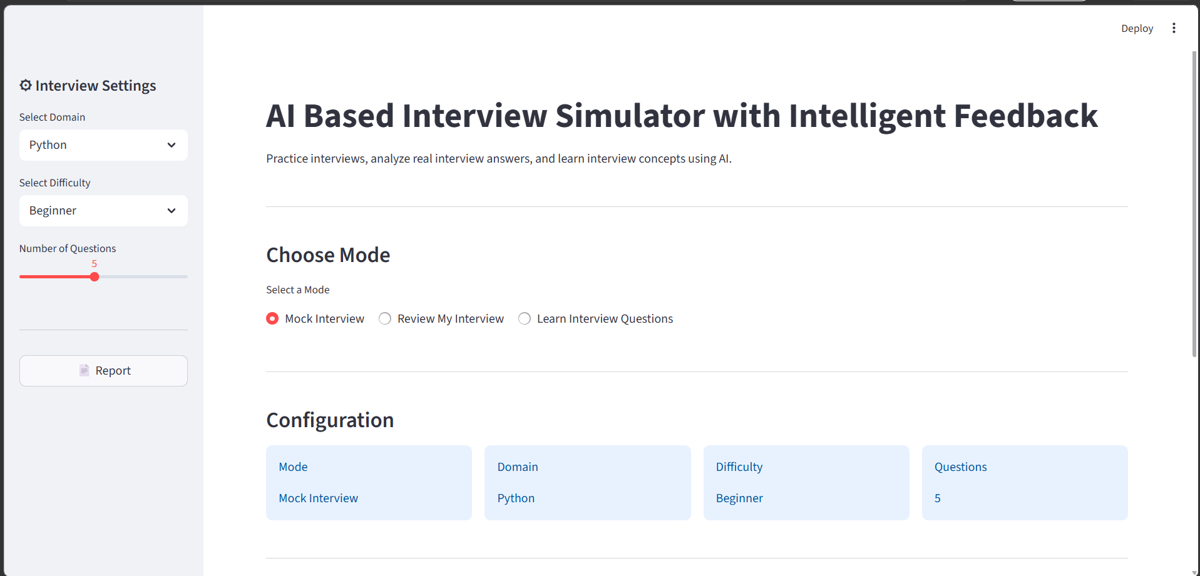

- Mock Interview Page
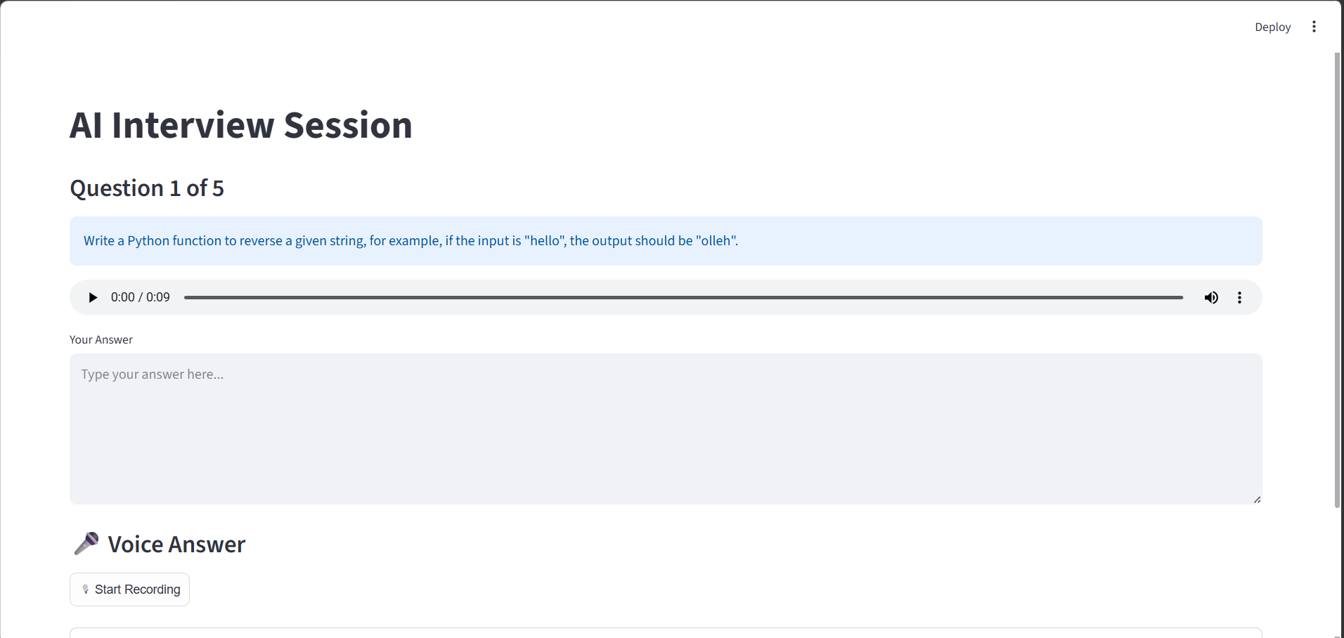

- Voice Recording and Speech-to-Text Feature
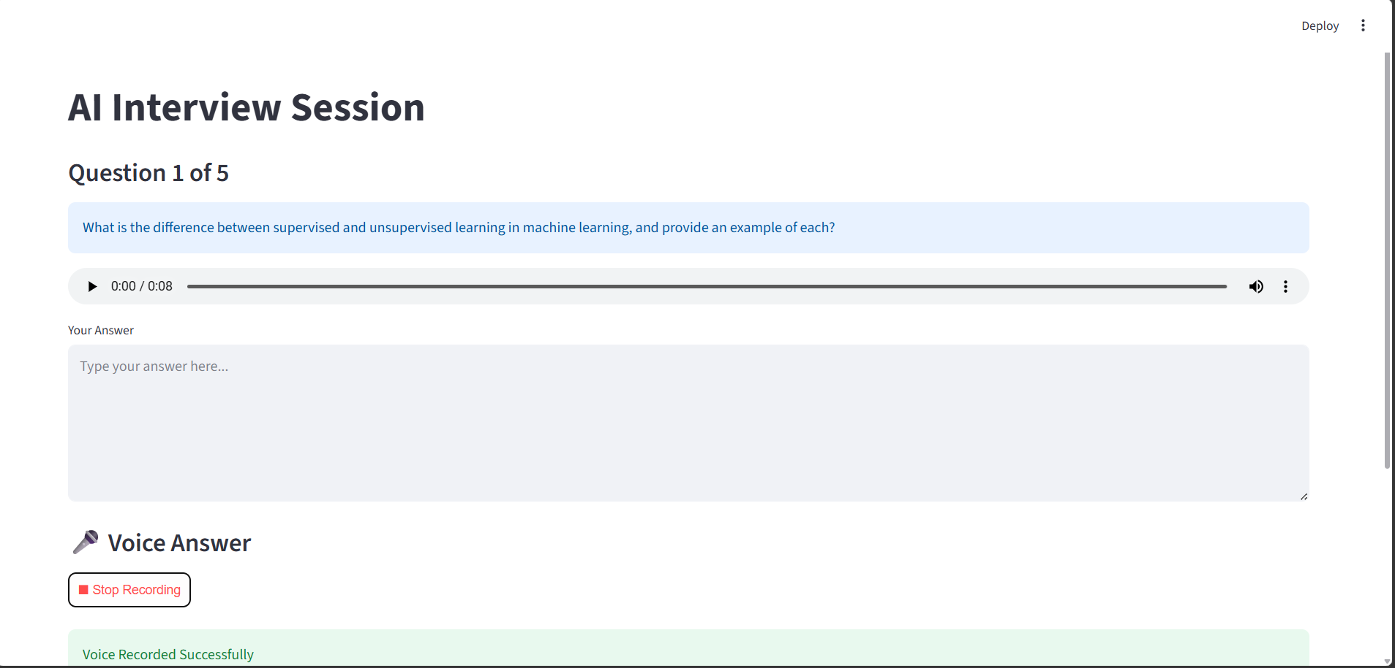

- AI Answer Evaluation Page
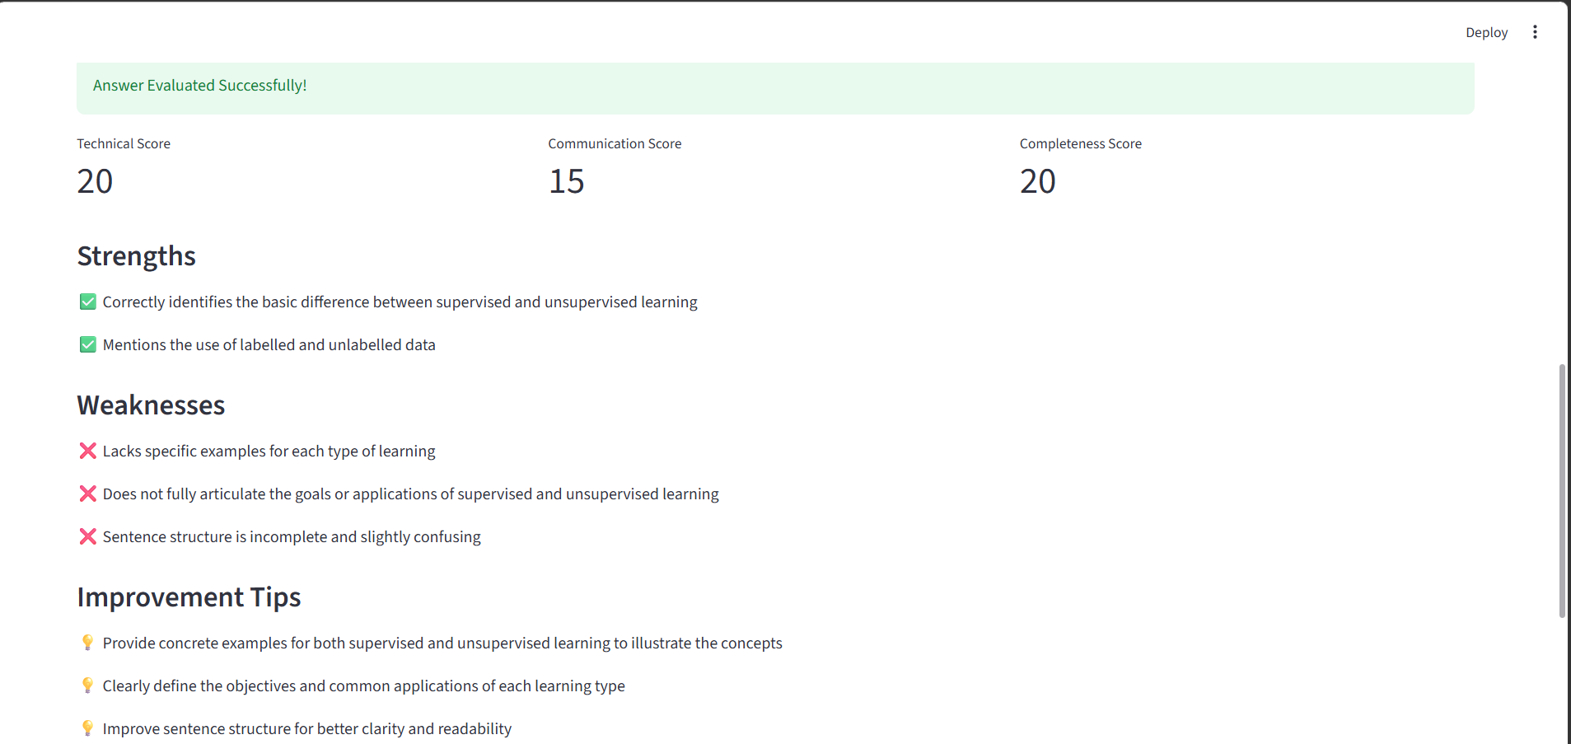

- Review My Interview Page
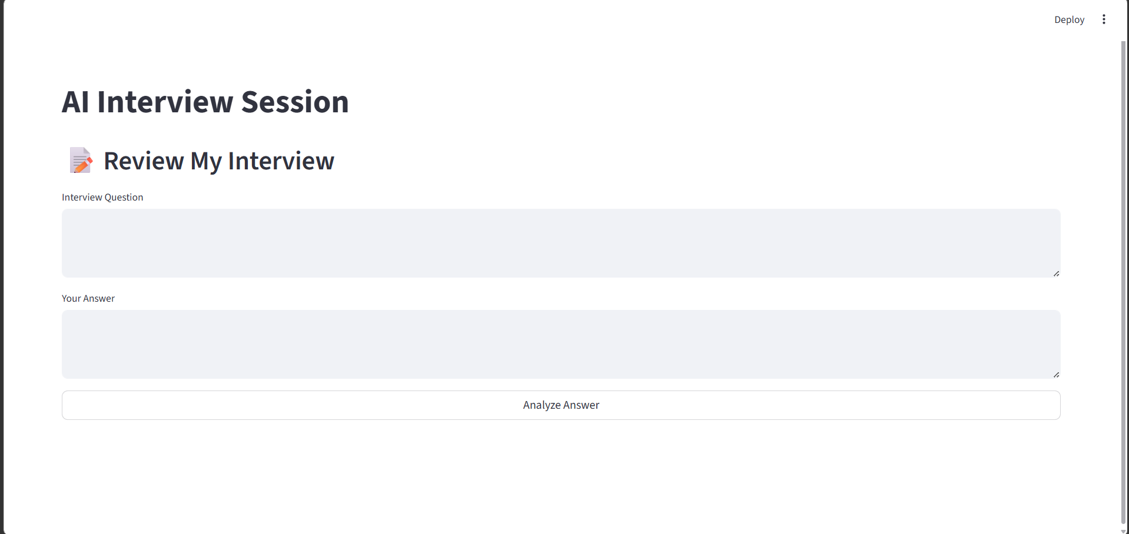

- Learn Interview Questions Page
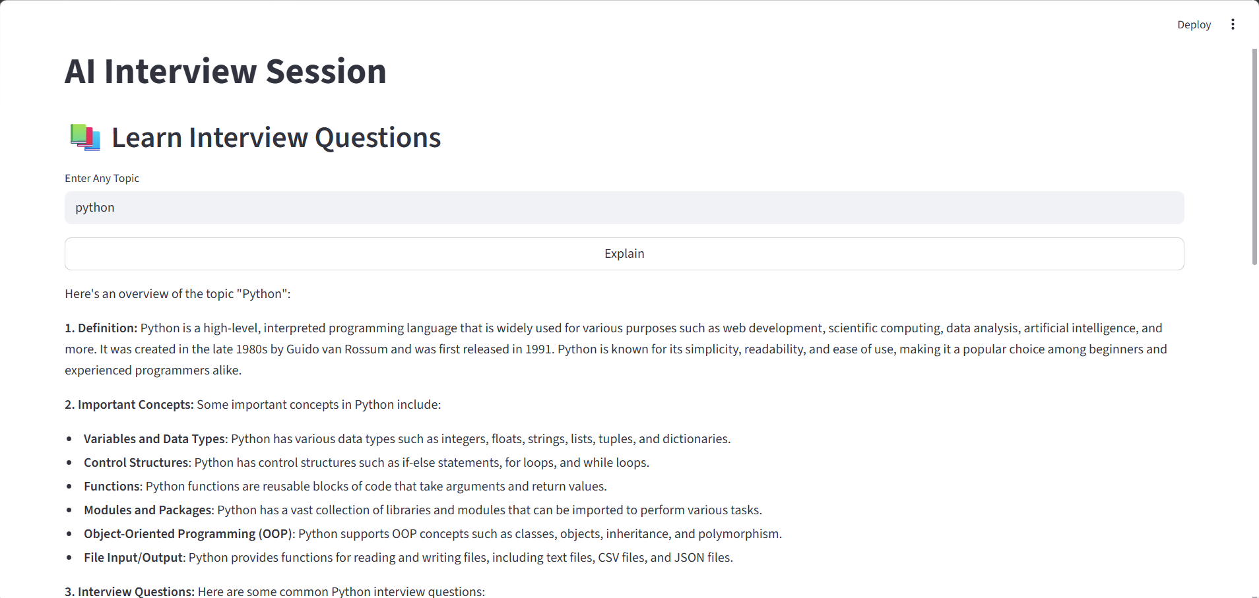

- Final Report Page
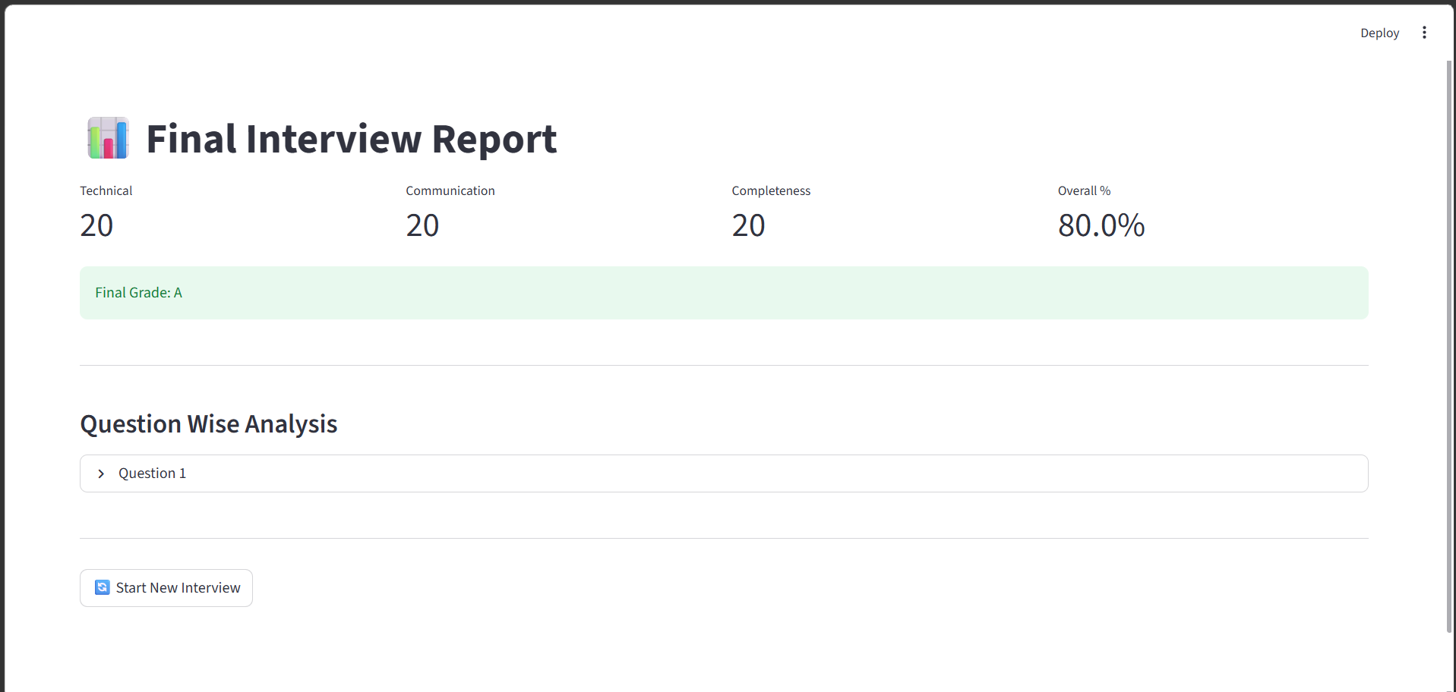

Project GitHub Link
GitHub Repository:
https://github.com/sure-trust/MUTHYALA-DEEPIKA-REDDY-g37-ai-ml

Learning and Reflection
New Learnings
Through this project, I gained practical knowledge of Python, Streamlit, Groq LLM integration, Speech-to-Text, Text-to-Speech, and GitHub. I also learned how to design an AI-based application, solve technical challenges, and improve my problem-solving, project planning, and software development skills.

Overall Experience
Developing this project was a valuable learning experience for me. During development, I faced challenges while integrating AI features, implementing speech recognition, and fixing technical issues, but solving them helped me improve my programming and problem-solving skills. This project also gave me confidence in building a complete AI application from design to deployment and motivated me to continue learning advanced AI technologies.

Conclusion and Future Scope
Conclusion
The AI-Powered Interview Simulation System was successfully developed to help students and job seekers improve their interview skills. The project achieved its objectives by generating AI-based interview questions, evaluating user responses, providing personalized feedback, and supporting both text and voice-based interviews. Overall, the system offers an effective and user-friendly platform for interview preparation.

Future Scope
The project can be enhanced by adding support for more technical domains and programming languages. Future versions can include video interview analysis, resume-based question generation, multilingual support, and detailed performance tracking. These improvements will make the system more intelligent and useful for a wider range of users.

